

**NAMA : SHABRINA QOTTRUNNADA**

**KELAS : 1G**

**ABSEN : 24**

**NIM : 2341760160**

**JOBSHEET 7**

**EXPERIMENT 1**

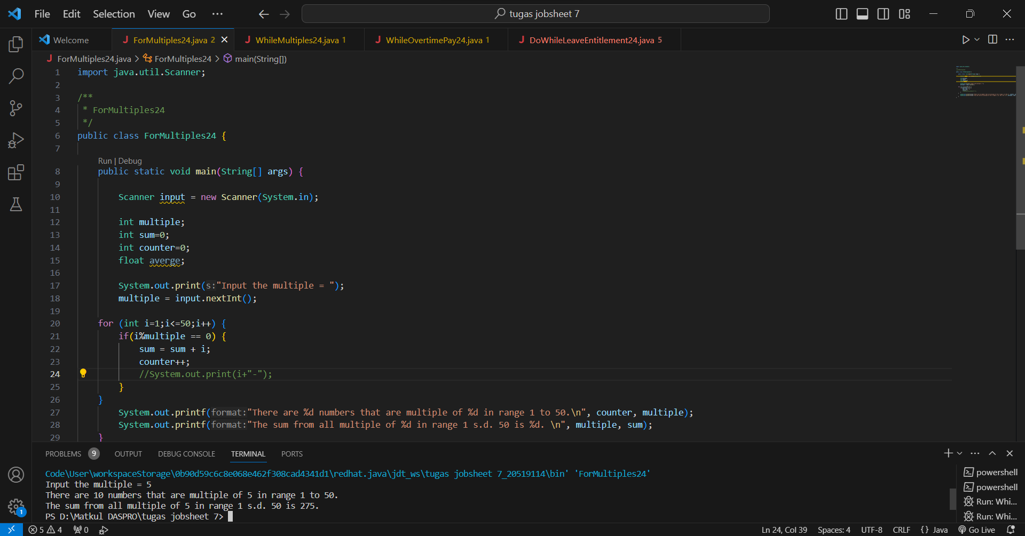

Questions :

1. There are 3 main components in FOR loop. Based on experiment 1 above, identify and explain these 3 components!

* Initialization 🡺 int i=1;
* Condition 🡺 i<=50;
* Looping 🡺 i++;

1. Explain how the following code works!

Answer :

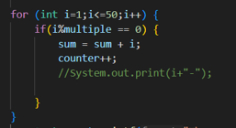

* for (int i=1;i<=50;i++) { 🡺 The loop will continue to run as long as the value of the variable 'i' is <=50.
* If(i%multiple == 0) { 🡺 To check if the variable 'i' is a multiple of the integer stored in variable 'multiple'.
* sum = sum + i; 🡺 To add variable 'i' to variable 'sum'.
* counter++; 🡺 To adds one unit to the value of the variable 'counter'.

1. Modify the existing code by adding a new variable to calculate the average of all the specified multiples! Push and commit the program code to GitHub.

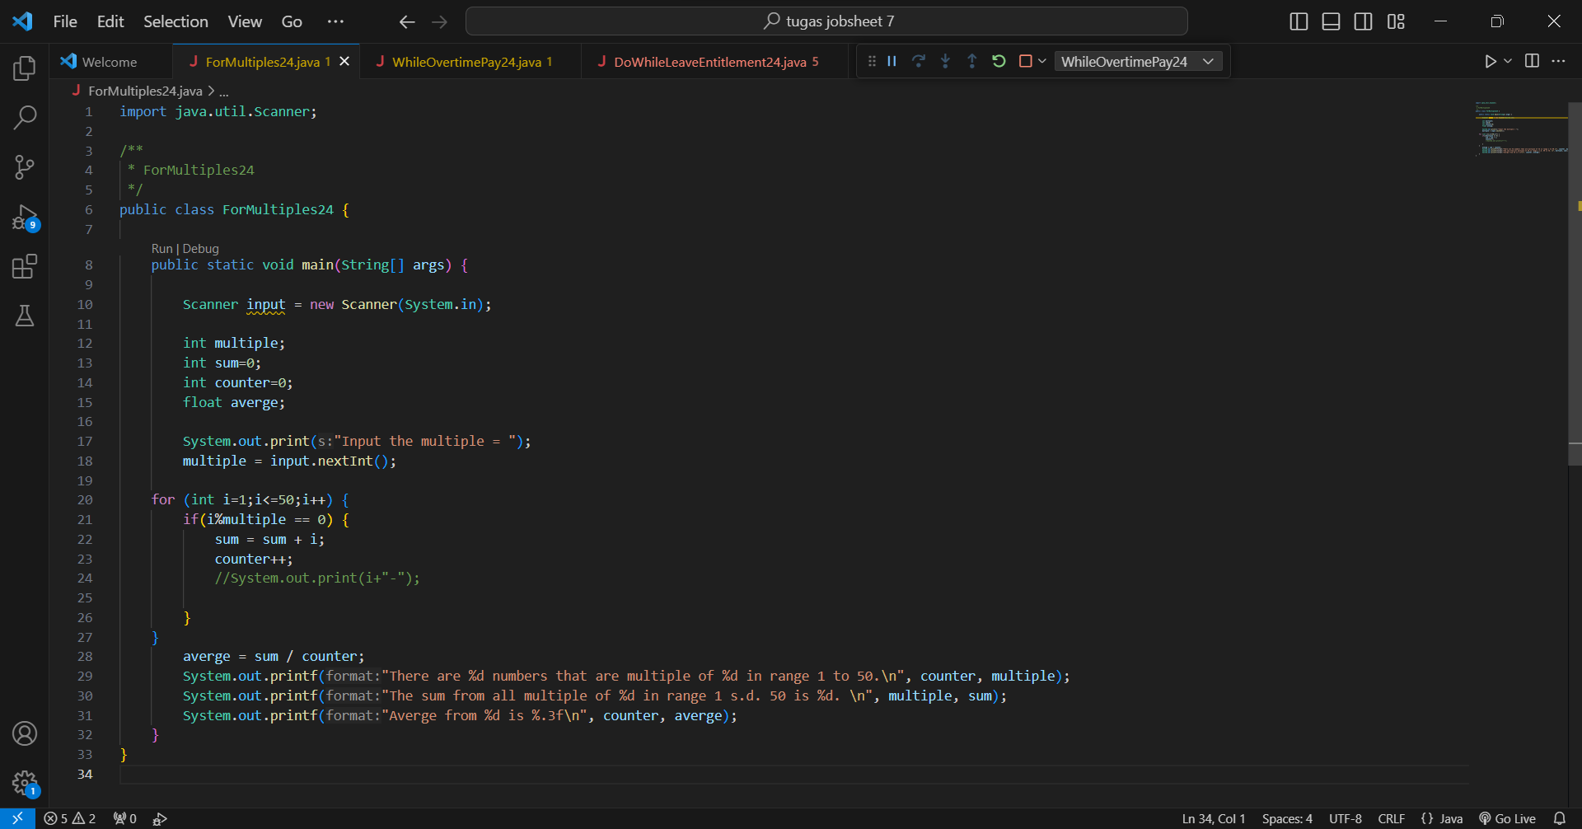



1. Create a new Java program file named **WhileMultiples**StudentIDNumber.**java**. Create the equivalent code by using while loop. Push and commit the code to GitHub.

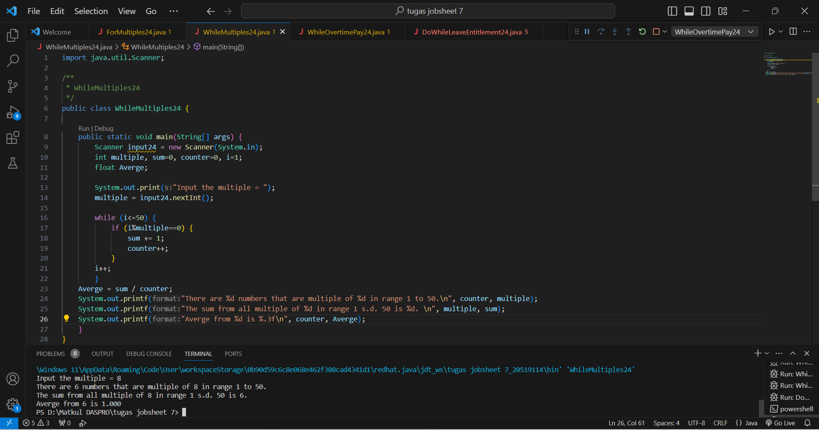

**EXPERIMENT 2**

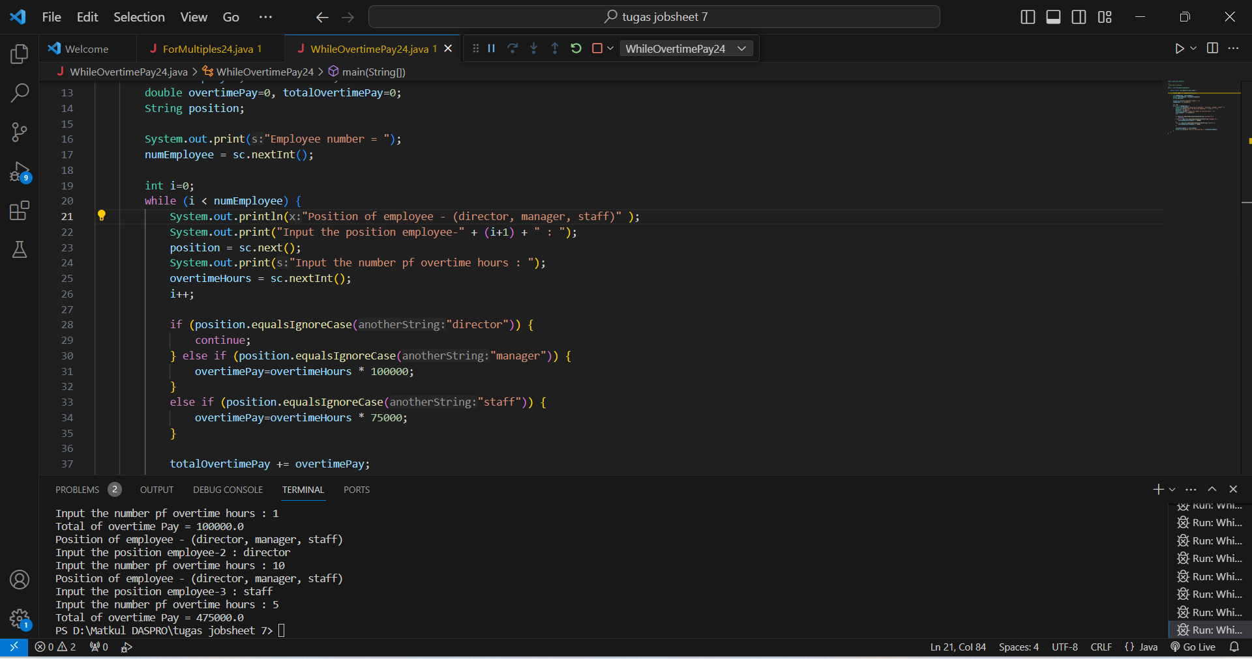

Questions :

1. Show the part of the program code used as a condition to stop the WHILE loop! How many times is the loop executed?

While (i < numEmployee) { 🡺 The program code used as a condition to stop the WHILE loop, because ‘i’ in the while loop will be executed when i is less than the number of employees inputted, so as long as there are still leftovers, the program will keep running until it is sufficient.

1. In this code,



What actually happens if the 'position' variable contains the value 'DIRECTOR'? What is the use of CONTINUE within the loop structure?

* If the 'position' variable contains the value 'DIRECTOR' by using the .equalsIgnoreCase command which functions to compare the letters input without paying attention to whether it uses lowercase or uppercase letters, then the program will still be able to run.
* while the use of CONTINUE in the loop structure is to skip excess or remaining code in the loop to continue to the next loop.

1. Why is the 'i++' iteration component placed in the middle, not at the end of the while block? Move 'i++' to the end of the while block, then run the program again by entering 'DIRECTOR' as the position for the first employee. What happens? Explain!

When i++ is moved to the end of the while block, the program will still continue executing the loop, because the i++ function is placed in the middle so that the loop we will create will stop when we execute it.

1. Modify the program code to handle invalid positions like the following example.

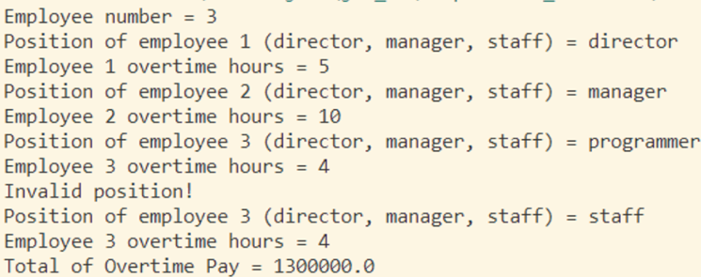

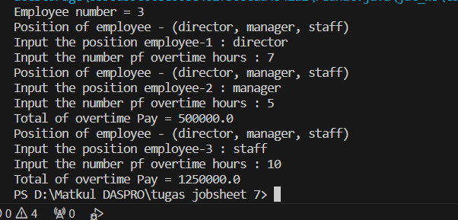

1. Commit and push the changes to GitHub.

**EXPERIMENT 3**

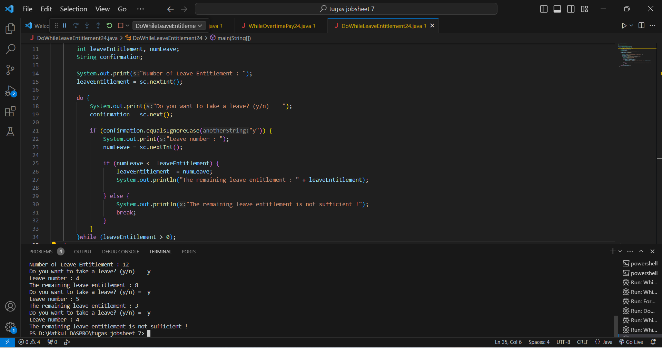

Questions :

1. What is the use of the BREAK within the loop syntax?

The break statement in a loop is used to quit the loop first. So when 'break' encounters a loop, the running program structure will exit the loop.

1. Modify the program so that if the number of leave days requested is greater than the remaining entitlement, the program does not stop, allowing the user to enter the number of days according to the entitlement.

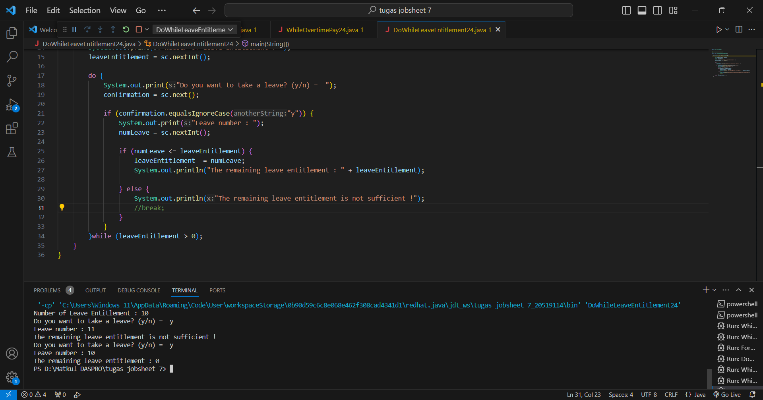

To modify the program if the number of days of leave requested is greater than the number of days of leave requested or there is a remainder, then the program will still continue to run, but we are told to enter the number of days until it matches the entitlement.

1. Commit and push the program code to GitHub.
2. When typing "t" as the confirmation input, what happens? Why?

If we type "t" as the confirmation input, then the program will continue to run as long as there are leave rights remaining, if the leave rights are no longer remaining, then the program will stop.

1. Modify the program code so that when the user enters "t" as the confirmation input, the program will stop.

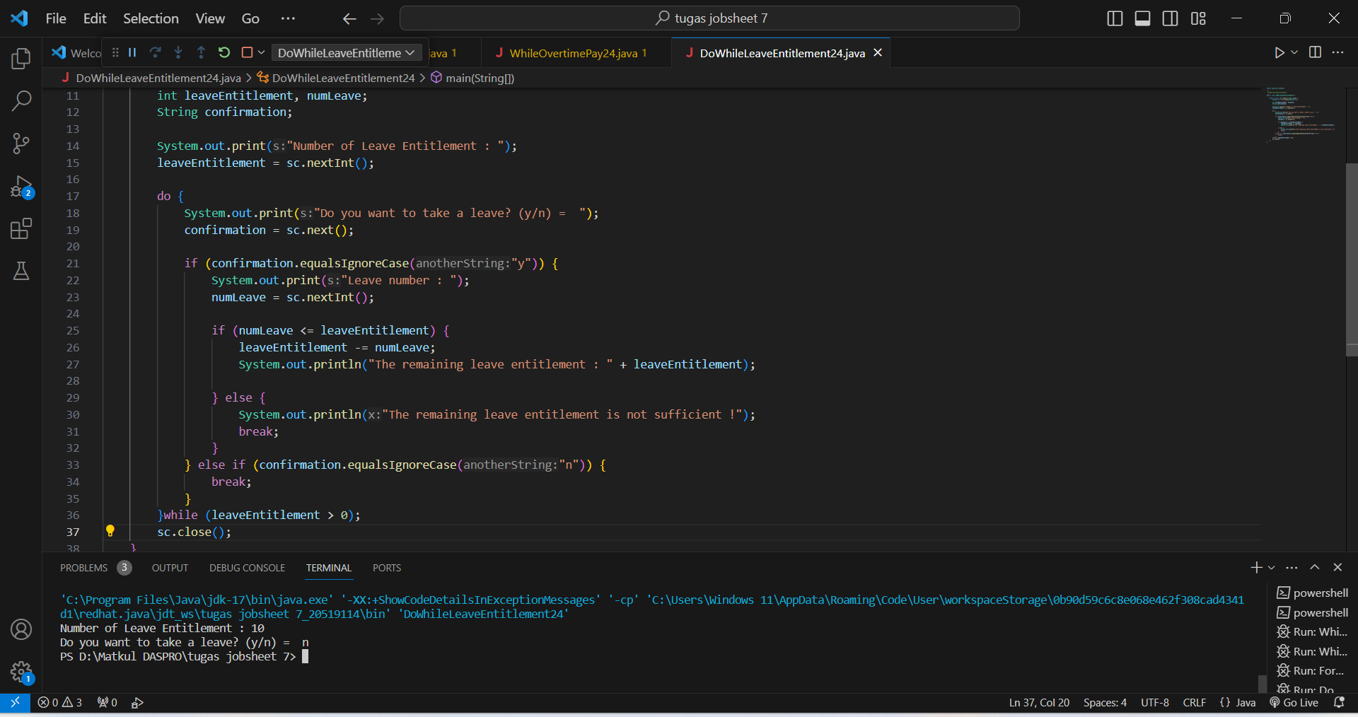

1. Commit and push the program code to GitHub.